Title (Times New Roman 14pt Bold)

Belinda M Yaris¹ andChris Sherman²(Time New Roman 12, no prefix or suffix and title, ie-Prof, Dr.etc)

¹Name of Organisation, City, Country
²Name of Organisation, Authority or Company, City, Country
Corresponding author’s E-mail: b.yaris@yahoo.com

Abstract
Abstract should be in Times New Roman 11justified in font. Limit each abstract to 250 words.

Abstract should be submitted in .doc or .docx format (Word 2007 or Higher).

Keywords: List 3 to 5 keywords in alphabetical order, separated by commas which can be uses for indexing purposes.

Margins and page allowance
Set out the paper on A4 size the same as this, with margins as described in Table 1.

Table 1. Margins to use in this paper

Margin | Size
Left | 25mm
Right | 25mm
Top and bottom | 25mm

For Microsoft Word users the Page Setup Dialog should appear as shown in Figure 1. Centre your Figures and Tables.

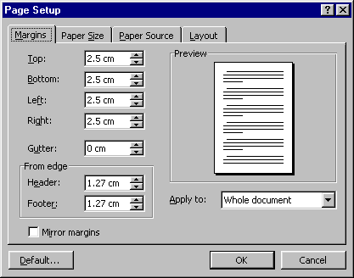
Figure 1. Page Setup Dialog Box (Margins) for formatting GSB National Seminar2023 Abstract for abstract volume.

