Title (Times New Roman 14pt Bold)

Belinda M Yaris¹ andChris Sherman² (Time New Roman 12, no prefix or suffix and title, ie-Prof, Dr.etc)

¹Name of Organisation, City, Country
²Name of Organisation, Authority or Company, City, Country
Corresponding author’s E-mail: b.yaris@yahoo.com

Abstract
Abstract should be in Times New Roman 11justified in italic font. Limit each abstract to 250 words.

Keywords: List 3 to 5 keywords, separated by commas.

Introduction (HEADING level 1 Times New Roman Bold 14 ALL Caps)
You must use this template in preparing your manuscripts for GSB National Seminar 2023. You should save this file in your disk and “save as” using file name based on the first author’s surname (e.g. YARIS.doc). You must use MS word in preparing your manuscript.

Full paper should be of maximum 10 pages long including tables, figures and list of references.

The text in the body of the paper will be in Times New Roman 11-point.

Heading Level 2 (Times New Roman 12 Bold)
This template, complete with header and footer formats, will make it easy to lay out the paper for the proceedings of GSB National Seminar 2023.

Manuscript should contain an introduction, main body (data, method, results, discussion, etc.) and a conclusion.

Margins and page allowance
Set out thepaper on A4 size the same as this, with margins as described in Table 1.

Table 1. Margins to use in this paper

Margin | Size
Left | 25mm
Right | 25mm
Top and bottom | 25mm

For Microsoft Word users the Page Setup Dialog should appear as shown in Figure 1. Centre your Figures and Tables.

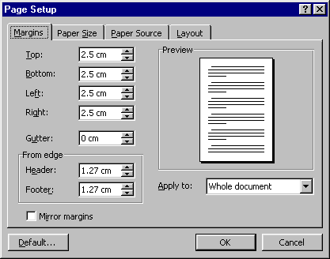
Figure 1. Page Setup Dialog Box (Margins) for formatting GSB National Seminar2023 papers

Page numbers should be placed on the outside bottom of each page in the footer margin. Number your pages 1, 2, 3, … of 'the total number of pages'. See Footer below.

Tables and Figures
Tables should be labelled Table 1, Table 2, … at the top of each table. Figures should be labelled as Figure 1, Figure 2, … below the figures.

Units
Use S.I. system.

Footers and headers
The header in Times New Roman 9-point italics should state the paper title on the left (abbreviated if necessary), and the last name of first author of the paper. The header will be suppressed on the title page.

The footer in Times New Roman 9-point italics should follow the format shown in the footer.

Equations
Equations should be centered as below:

A = b + yt_{j} (1)

The equation should be separated by a blank line above and below, and the equation number should be right aligned on the right margin. When you reference equations in the text, use the equation number, e.g. using Equation 3, it can be seen that they are correlated.

ACKNOWLEDGMENTS
We acknowledge Mr X in Organisation Y.

In-TEXT REFERENCES
For in-text references, please see the examples below.

The paper adopted a methodology as suggested by Smith (1980), Smith and Jones (2008), Smith et al (2010), Sydney Water (2011) and BWDB (2014).

References

Imrose K, Jones D (2013).Water price in Australia – a comparative study considering data during 1950 to 1998, Accessed via www.waterprice.australia on 22 Jan 2012.

Kulman PR, Rahman A (2012). A new regional flood estimation technique for north Australia considering region of influence and catchment characteristics data, Technical report, University of Western Sydney, 46 pp.

Park BN, Rahman A, Haddad K, Robinson CR (1999). Towards a new regional flood methods in Australia based on canonical correlation analysis, Australian Journal of Water Resources, 4, 23-32.

Yang X, Lu K, Henry R (2011).Water data analysis, 3rd edition, Wiley, 306 pp.

